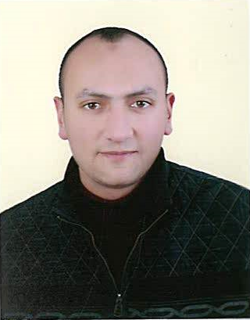
Electrical Engineer since 2012

Name: Eslam Awwad Mohammed
Address: Egypt, 13775
Mobile: +201273299428
E-mail: engeslam12@yahoo.com

Personal Data

Nationality: Egyptian Place of birth: Saudi Arabia
Passport No: A18644890 Date of birth: Oct, 10, 1989
Driving License: Available

Education

College: Benha Faculty of Engineering, Egypt
Degree: Bachelor of Electrical Engineering, 2012
Grade: Good / 70 %

Experience

1- Maintenance Engineer (Current Job)
Sino Tharwa Drilling Co, Egypt

- Ensure all electrical systems & Devices are maintained, serviced, tested
& installed accordance the electrical standards and good industry practice
- Rig Type: Diesel Electric driven with SCR and 2000 HP draw works
- Main power: 3 CAT 3512B Generators, 1714 KVA 1200KW 50HZ 600V 1828 A
- SCR Unit Contains:
5 SCR bridges 600VAC to 750VDC, Transformer 600VAC to 380VAC & MCC
- 9 X DC Motors, Series Connection, 800KW
6 for 3 Triplex Pumps, 2 for Draw Work, 1 for Rotary
- VFD Unit controls speed & Torque for Top Drive Motors
- Top Drive Motors: 2 X AC Motors, Varco, TDS 11-SA, 400KW
- HMI (Drill Watch) & PLC to monitor & control Drilling Process
- Fire system & H2S System (4 Zones) are Protection from firing & H2S Gas
- Camera, Sound & Telephone Systems

2- Projects Engineer (1-Year)
Marbella Foods Co, Egypt

- Design Single Line Diagram for Production Lines: • Control & power panels
• Mechanical parts (coupling shafts, gears) • Production halls layout
- Supervise projects, follow up until delivery & Coordinate with others
- Work on SAP system: create project, purchase request & follow up
- Projects: Sugar transport system - Piping Line with Double Jacket to transport
Raw gum - Vertical & Horizontal Packaging machines - Automation systems
- Prepare for the projects: (SOP – SP's list – SLD - PLC & HMI programs)

Courses

- Generator
Principles of electric generator
Generator voltage control circuit
Generator speed control
Generator Protections
- SCR
Electric Motors
Motor Control Center
SCR Principle
SCR Wiring
SCR Troubleshooting
- Top Drive
Principles of VFD
VFD control circuit
VFD parameters, communication with PLC
VFD troubleshooting
- Refrigerators & Air Conditioning
Principles of refrigeration and air-conditioning system
Refrigerators and air conditioning system mechanical circuits and protections
Air Conditioning system & Refrigerators Electric control circuits
Air Conditioning system & Refrigerators Trouble shooting
- Classic Control
- Electrical Distribution
- Industrial Automation (PLC - Sensors - Solenoids -Motors)

Training

- Toshiba
- Cairo Refinery
- Kaha Military Factory

Skills: Dealing with

- Electrical Power Systems: Generator, Transformer, UPS, SCR & VFD
- The Integration between Main Power Distribution, UPS & Emergency system
- Types of Motors & its Drives (AC, DC, Servo & special Motors)
- Automation systems: HMI, PLC, SCADA & DCS
- Hospital Instrumentation (ECG - MRI - Echo) & Clinical equipment management
- Microcontroller (8051 & PIC) projects by (assembly & C++) languages
- Engineering Packages: AutoCAD, Operating Systems & MATLAB
- Computer skills: (Word - Excel - PowerPoint)

Languages

• English: Very good in writing, reading & conversation
• German: good in writing, reading & conversation

